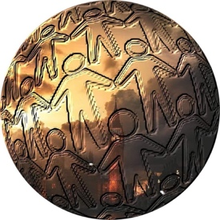
The Global Goodwill Ambassadors of
The Republic of The Gambia
A Program of The Zaid Ibn Harith Islamic Center
New York, New York and Banjul, The Gambia
(770) 870-8045 (iPhone/WhatsApp)
Globalgoodwillambassadors@gmail.com

Statement of Certification
GGA-TRTG Official Board of Directors

Date: May 1, 2019

TO: The Republic of The Gambia Ministry of Justice

Office of Registration of a Charitable Organization/Association/Foundation

To whom this may pertain:

This statement comes to both verify and register the Official Global Board of The Global Goodwill Ambassadors of The Republic of The Gambia. This organization is listed, registered and funded through The Zaid Ibn Harith Islamic Center. list consists of seven (7) members that consist of elected officers of shall be as follows:
- Dr. Ameena Ali CEO/Executive Director - This will be the connection between the Board, the Volunteers and Interns and the Program Managers.
- Fatou Yusuf Jallow President – Executive Program Manager; overseer of the day-to-day functions of the area and regional programs. Responsible to progress to the Stakeholders and Donors to the organization.
- Binta Minteh Vice President – Assist to the President; responsible to troubleshoot policies and protocols of the organization for growth and expansion.
- Abou Baldeh Treasurer - Fiscal responsibility to the Organization: there will be two people involved in this process for proper checks and balances.
- John Loum Fundraiser/Public Relations – Brand Ambassador; responsible for public promotion and social media presence.
- Hans Loum Secretary – Corporate Scribe; holder of the meeting minutes and scheduler of events, meetings and panels.
- Jamanty NK Manjang Parliamentarian - Shariah-Compliant Officer; keeper of the protocols and plans of the organization and the legal correspondence for the organization.
The date of appointment of this Board is effective as of the date of this statement and will be in effect until the First Friday in May, 2020, when new elections will be held allowing the entire member body of the organization to vote for its officers.
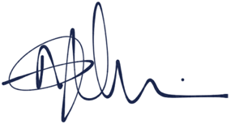
This statement is true and in fact and will be certified with the signatures affixed below.

Printed Names: Dr. Ameena J. Ali Signature _____________________________________
Fatou Y. Jallow Signature _____________________________________
Binta Minteh Signature _____________________________________
Abou Baldeh Signature _____________________________________
Hans Loum Signature _____________________________________
John Loum Signature _____________________________________
Jamanty NK Manjang Signature _____________________________________

